**Table of Contents**

Overview ................................................................................................................................................ 1

HSA Contribution General Instructions .................................................................................................. 1

File Layout ........................................................................................................................................... 2-3

Sample Layout ........................................................................................................................................ 4

Important Notes ..................................................................................................................................... 5

***A Secure EDI connection will need to be established with Cigna in order to transmit files.***

**Overview**

This document provides information about the format and layout of the HSA contribution file.

# HSA Contribution General Instructions

Each file must contain;

* A header record (The header record is ***always*** on the first line), and
* A detail record for each applicable participant

Each field is put into a separate column based on the layout below.

* The detail records should ***only*** be sent for participant who have enrolled in the HDHP/HSA with Cigna, and have contributions to be posted***.***
* ***Zero dollar contributions should not be included in the file***
* ***Negative amounts cannot be included on the file***

**Comma delimited txt format**

**File Layout- Header Record**

|  |  |  |  |  |  |  |
| --- | --- | --- | --- | --- | --- | --- |
|  | **Field** | **Max** | **Contents (Sample)** | **Field Validations** | **Comments** | **Mapping** |
| **1** | **FED ID** | 9 | “123456789” | Must be numeric  Cannot exceed maximum length  Must be a valid value and exist in the HSA Bank ‘system | Federal ID | CmmFedtaxId |
| **2** | **Clearing Account** | 10 | “1234567890” | Must be numeric  Cannot exceed maximum length  Must be a valid value and exist in the HSA Bank ‘system | Clearing account at HSA Bank  where funds will be sent  HSA Bank will provide the value for this field | 8000281617 |
| **3** | **Email** | 40 | “email@confirmations.com” | Must be valid email  Cannot exceed maximum length | Client’s email address for file confirmations | [lhines@billtrust.com](mailto:lhines@billtrust.com) |
| **4** | **Date** | 8 | “02052020” | Must be in MMDDYYYY format  Cannot exceed maximum length  Must be numeric  Must be within the last 7 days | Date file is summited to HSA Bank | Today’s date |
| **5** | **Number of**  **Detail**  **Records** | 5 | “10” | Must be numeric  Equal to the number of contribution records in the file | Number of contribution records submitted | Count of records on file |
| **6** | **Amount** | 12 | “50000” | Must be numeric  Cannot exceed maximum length  Amount must equal the sum of the dollar amount in the contribution details | DDDDCC  (D = dollar, C = cent, no  decimals)    Ex. 500000 = $5,000.00 | Sum(PdhEECurAmt) where PdhEEdedcode = HSA plus Sum(PdhERCurAmt) where PdhEEdedcode = HSAER for all lines |
| **7** | **Source** | 3 | “WRE” | Must be alphanumeric  Cannot exceed maximum length  Must be one of the valid values listed below:   * ACH * WRE | ACH = Funds sent to clearing account via ACH    WRE = Funds sent to clearing account via wire | ACH |

**File Layout- Detail Record**

|  |  |  |  |  |  |  |
| --- | --- | --- | --- | --- | --- | --- |
|  | **Field** | **Max** | **Contents**  **(Sample)** | **Field Validations** | **Comments** |  |
| 1 | Last Name | 20 | “DOE” | Must be alpha characters (including spaces)  Values longer than max length  will be truncated | All text should be capitalized, no punctuation | eepnamelast |
| 2 | First Name | 20 | “JOHN” | Must be alpha characters (including spaces)  Values longer than max length  will be truncated | All text should be capitalized, no punctuation | eepnamefirst |
| 3 | Account Number | 17 | “12345678” | Must be numeric  Must be at least eight digits  Must be a valid value and exist in HSA Bank’s system | Numerical, no dashes    **Conditional-**  **Required if SSN field is left blank** | Leave blank |
| 4 | SSN | 9 | “123456789” | Must be numeric  Must be nine digits  Must be a valid value and exist in HSA Bank’s system | Numerical, no dashes  **Conditional-**  **Required if Account# field is left blank** | eepssn |
| 5 | Transaction  Amount | 12 | “5000” | Must be numeric  The amount cannot exceed the maximum allowable amount for the current year for Transaction Type ER or EX.  The amount cannot exceed the maximum allowable amount for the previous year for Transaction Type PR or PX.  ***\*\*\*Cannot contain negative amounts\*\*\**** | DDDDCC  (D = dollar, C = cent, no decimals)    Ex. 500000 = $5,000.00 | Sum (PdhEECurAmt) where PdhEEdedcode in (HSA) and send on EX transaction type line  Sum (PdhERCurAmt) where PdhEEdedcode in (HSAER) and send on ER transaction type line |
| 6 | Transaction Type | 2 | “EX” | Must be alphanumeric  Cannot exceed maximum length  Must be one of the valid values listed below:   * EX * ER | Contributions: accounts to be credited.  *(Please note coding to ensure proper processing)*  ***Current Year:***  EX = Employee Pre-Tax (cafeteria plan)  ER = Employer | If eeddedcode = HSA send EX  If eeddedcode = HSAER send ER |
| 7 | Description | 80 | “CONTRIBUTION February 2020” | Must be alphanumeric  If description field contains the calendar year, the year must represent this year, next year or last year (where year equals year from the date in the header)    The year must correspond to the Transaction Type | **Do not leave this field blank**  Contents must include the calendar year to which the contribution should be    Ex: “CONTRIBUTION February 2020” | If eeddedcode = HSA send EE CONTRIBUTION YYYY with YYYY representing the current 4 digit year  If eeddedcode = HSAER send ER CONTRIBUTION YYYY with YYYY representing the current 4 digit year |

**Sample Transaction File (Notepad Current Year):**

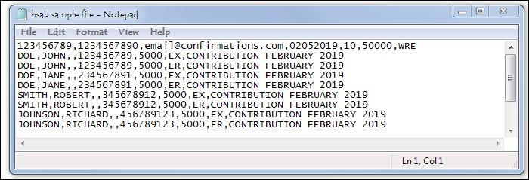

**Sample Transaction File (Notepad Prior Year)**

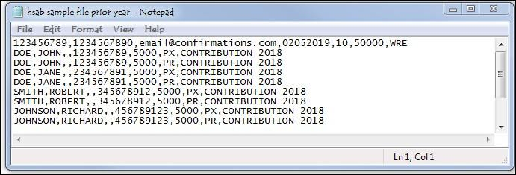

**Important Notes:**

1. Multiple files can be submitted per day, (specifically for those who have multiple divisions).
   1. Files will need to be sent 5 minutes apart to avoid being overwritten.
   2. Date and Time Stamp YYYYMMDDHHMMSS

i. Example OKH1000__okh0001i.12345.hsab_blk. 20200205144219.txt

1. File and matching funds must be received before 11am CST to guarantee same day processing. If received after 11am CST, contributions will process on the next business day.

1. If the Account Number field is not present, SSN ***must*** be present. If SSN field is not present, the Account Number ***must*** be present.

1. 9 digit SSN ***must*** be present, NO dashes.
   1. Be sure to provide leading zero, if applicable by formatting the cells to “Text”



1. It is imperative to code Transaction Types as either “***prior***” or “***current***” year, and to include the contribution year in the description to ensure correct IRS reporting. Contributions will be processed according to the file submitted.

1. Future date files can only be dated 14 days in the future

1. All letters must be ***upper case***. Content data should appear ***without*** punctuation (except for email fields). Names should appear ***without*** dashes or hyphens.

1. The file will be comma delimited text file. The field size represents the maximum number of characters (including spaces) supported. Excess characters will be truncated

**For troubleshooting, please contact your assigned Cigna HSA Specialist or Cigna Technical Specialist**